YISU Travel GmbH
Laravel Backend

- Powershell als Admin und:
# Run as administrator...
Set-ExecutionPolicy Bypass -Scope Process -Force; [System.Net.ServicePointManager]::SecurityProtocol = [System.Net.ServicePointManager]::SecurityProtocol -bor 3072; iex ((New-Object System.Net.WebClient).DownloadString('https://php.new/install/windows/8.4'))
Version: v11.5.0
LARAVEL v11.36.1 plugin v1.1.1
ausführen.

- https://getcomposer.org/download/
Danach: composer global require laravel/installer (im powershell als admin )
Danach: npm install && npm run build (im intellij ordner backend ordner)
composer install (mit git terminal maybe )
https://laravel.com/docs/11.x/installation
https://www.youtube.com/watch?v=WumgBzENYYk&t=308s

- Ein Ordner stellen und:
  - Laravel new YISUTravelBackend
  - Starter kit: none
  - Pest Framework
  - MySQL nutzen
  - ➜ cd YISUTravelBackend
  - ➜ npm install && npm run build
  - ➜ composer run dev
  - php artisan install:api
- Checke .evn file um MySQL Daten einzutragen

- Du kannst in IONOS dir die Daten ansehen oder MySQL80 starten, Datenbank schema ist wichtig

- composer require laravel/sanctum
- php artisan vendor:publish --provider="Laravel\Sanctum\SanctumServiceProvider"

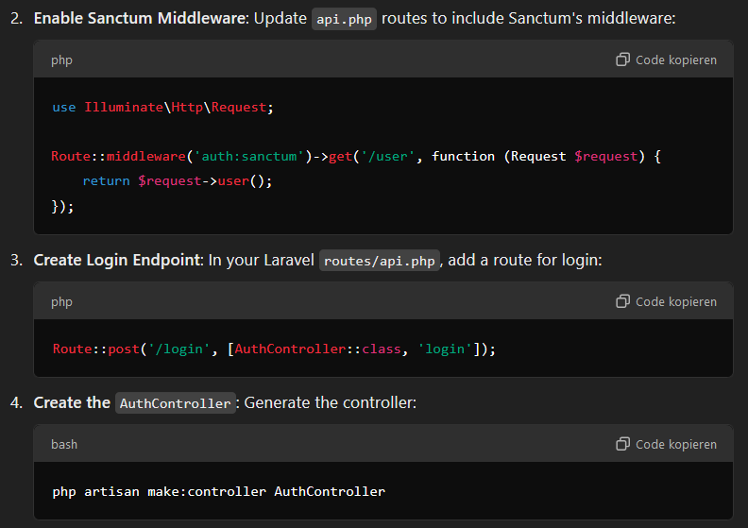
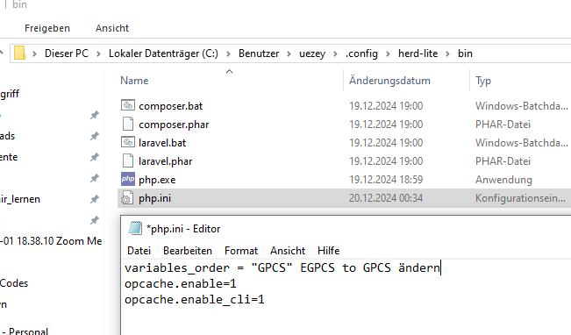

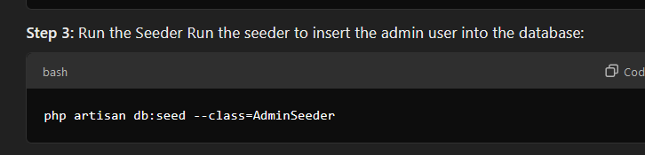

Für Datenbank lokal:
https://dev.mysql.com/downloads/workbench/

Laravel IONOS:
Composer version 2.8.4 2024-12-11 11:57:47

Erstelle Subdomain:
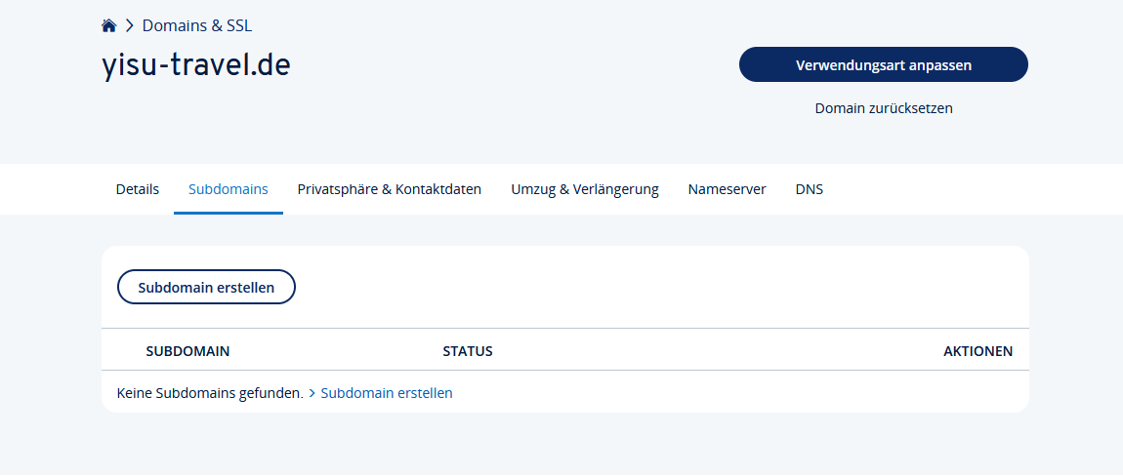

Folgende dem Video:
https://www.youtube.com/watch?v=Qqp9qPgULEA

php artisan key:generate

Um Database Tabellen zu migraten, füre das aus:
php8.3 artisan migrate

1. Set Up Laravel Authentication API
Ensure your Laravel backend has an authentication system set up. Here’s how to proceed:
- Install Laravel Sanctum for API Authentication:

composer require laravel/sanctum
php artisan vendor:publish --provider="Laravel\Sanctum\SanctumServiceProvider"
php artisan migrate

- Enable Sanctum Middleware: Update api.php routes to include Sanctum's middleware:

use Illuminate\Http\Request;

Route::middleware('auth:sanctum')->get('/user', function (Request $request) {
return $request->user();
});

Create Login Endpoint: In your Laravel routes/api.php, add a route for login:
Route::post('/login', [AuthController::class, 'login']);

Create the AuthController: Generate the controller:
php artisan make:controller AuthController

Implement the login method:
use Illuminate\Http\Request;
use Illuminate\Support\Facades\Auth;

public function login(Request $request)
{
$credentials = $request->only('name', 'password');

if (!Auth::attempt($credentials)) {
return response()->json(['message' => 'Unauthorized'], 401);
}

$user = Auth::user();
$token = $user->createToken('authToken')->plainTextToken;

return response()->json(['token' => $token, 'user' => $user]);
}

- Update Angular Frontend
ng generate service auth

import { Injectable } from '@angular/core';
import { HttpClient } from '@angular/common/http';
import { Observable } from 'rxjs';

@Injectable({
providedIn: 'root',
})
export class AuthService {
private apiUrl = 'http://your-laravel-api-url.com/api';

constructor(private http: HttpClient) {}

login(credentials: { name: string; password: string }): Observable<any> {
return this.http.post(`${this.apiUrl}/login`, credentials);
}
}

Update Angular Component
Update the onsubmit method in your AdminLoginComponent:

import { Component } from '@angular/core';
import { FormBuilder, FormGroup, Validators } from '@angular/forms';
import { AuthService } from './auth.service';

@Component({
selector: 'app-admin-login',
templateUrl: './admin-login.component.html',
styleUrls: ['./admin-login.component.css'],
})
export class AdminLoginComponent {
contactForm: FormGroup;

constructor(private fb: FormBuilder, private authService: AuthService) {
this.contactForm = this.fb.group({
name: ['', Validators.required],
password: ['', Validators.required],
});
}

onsubmit(): void {
if (this.contactForm.valid) {
const credentials = this.contactForm.value;
this.authService.login(credentials).subscribe({
next: (response) => {
console.log('Login successful', response);
localStorage.setItem('authToken', response.token);
},
error: (err) => {
console.error('Login failed', err);
},
});
}
}
}

3. Protect Angular Routes
To secure routes in Angular, you need a guard:

ng generate guard auth

import { Injectable } from '@angular/core';
import { CanActivate, Router } from '@angular/router';

@Injectable({
providedIn: 'root',
})
export class AuthGuard implements CanActivate {
constructor(private router: Router) {}

canActivate(): boolean {
const token = localStorage.getItem('authToken');
if (token) {
return true;
}

this.router.navigate(['/login']);
return false;
}
}

Apply Guard to Routes: In your app-routing.module.ts, use the guard:

import { AuthGuard } from './auth.guard';

const routes = [
{ path: 'dashboard', component: DashboardComponent, canActivate: [AuthGuard] },
{ path: 'login', component: AdminLoginComponent },
];

